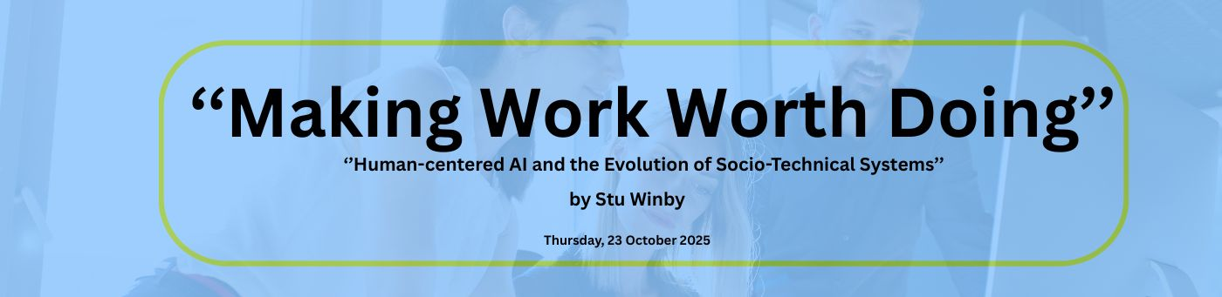

Meeting notes: ‘Human-centered AI and the Evolution of Socio-Technical Systems’
Stu Winby
23.10.2025

Overview:
The meeting featured Stu Winby presenting on the evolving relationship between technology, organization, and human-centered AI (HCAI), emphasizing the need for socio-technical systems (STS) to adapt through a co-evolutionary model integrating AI with human creativity and ethics. Participants discussed challenges including job displacement, the importance of redefining organizational language, design labs as continuous capabilities, and the critical role of cross-functional collaboration and governance in AI implementation. The group agreed on the urgency for the STS community to reframe its approach to align with contemporary AI-driven organizational changes and committed to further exploration through case studies, interdisciplinary dialogue, and upcoming conferences.

Key Themes and Topics

1. Historical Context & Organizational Evolution
- Stu shared his extensive background in socio-technical design, from working on early aerospace projects to managing innovation firms in Silicon Valley.
- Technology has always been a driver of organizational change, historically cycling through dominant designs (Industrial Revolution to present).
- Currently, AI represents a new dominant technology, causing organizational discontinuities.
- Organizations typically lag behind technology evolution, leading to adaptation challenges.

2. Modern Organization and Operating Models
- The classical hierarchical and siloed organizational structures are becoming obsolete.
- Modern organizations combine advanced technology, data, and people into dynamic, reconfigurable work systems or microstructures.
- Example: Tesla’s decentralized decision-making with real-time data access and empowered work teams illustrates a shift towards the "operating model" becoming the organization.

3. Human-Centered AI (HCAI)
- HCAI stresses the integration of AI systems with human values, ethics, and collaborative decision-making rather than automation solely for efficiency or headcount reduction.
- Guiding principles include user control and empowerment, transparency, accountability, sustainability, and governance structures.
- HCAI aims to optimize joint human-AI performance resulting in improved creativity, innovation, and competitiveness.
- The risk of widespread job displacement due to AI-driven automation was acknowledged but viewed alongside opportunities for societal restructuring and redesign.

4. Socio-Technical System (STS) Design vs. Strategic Organization Design
- STS focuses on joint optimization of social and technical subsystems, offering superior performance gains in redesign projects compared to traditional top-down strategic designs.
- The Human-Centered AI system is inherently a socio-technical system, and the two fields are converging and should learn from one another.

5. Evolving Practices in Organizational Design for AI
- The human unit of analysis varies widely (from individuals to entire ecosystems).
- Variances or variabilities in work systems acting as problem indicators; empowered workers closest to variances help eliminate inefficiencies.
- Agile methodologies, while influential, do not fully substitute for comprehensive socio-technical systems approaches.
- The importance of design labs and rapid prototyping in organizational redesign with AI was emphasized, incorporating cross-functional teams, customers, and ecosystem inputs.

6. Emerging Organizational Models
- Hybrid work systems (often virtual, crowd-sourced, global teams) exemplify new social-technical designs enabled by AI and digital technologies.
- "Flash Teams" (short-lived, dynamic teams) showcase rapid reconfigurability aligned with AI workflows.
- AI Automation Engineers within work systems identify and eliminate variances, freeing human workers to focus on higher-value tasks (creativity, strategy).

7. Human-Centered AI Socio-Technical Design Model
- Stu introduced a 4-step organizational architecture model combining people, processes, data, and technology with an emphasis on alignment and fit to achieve high performance.
- Extensive user-centered research, continuous feedback loops, and governance are essential to ensure ethical and effective AI deployments.
- A maturity model was presented to help organizations assess and improve their HCAI implementation from initial readiness to full optimization.

Discussion Highlights

Challenges and Concerns
- Tensions exist between AI-driven efficiency models (leading to job displacement) and HCAI's human-supportive goals.
- Regulatory and political variability (e.g., EU AI Act versus US policy shifts) complicates alignment on ethics and governance.
- Diverse definitions and understandings of AI create confusion; a call for clearer, shared language and frameworks was universally supported.
- The risk of superficial adoption of "shiny objects" like Agile or trendy organizational models without robust STS principles was noted.
- The need for organizational change agents capable of bridging AI, technology, and socio-technical system design was emphasized, as these skills are currently scarce.

Opportunities and Strategic Directions
- The Roundtable has a unique opportunity to reframe STS language, integrating HCAI concepts to attract practitioners and researchers.
- Design labs were recognized as a critical organizational capability to foster continuous adaptation, learning, and innovation.
- The potential for interdisciplinary collaboration among computer scientists, social scientists, psychologists, and organizational designers was stressed.
- Experiential learning through design labs can build the "muscle" for effective human-AI partnerships in work systems.
- Global differences in values, interests, and power dynamics must be addressed openly for HCAI to be sustainable.

Community and Future Work
- Participants expressed interest in:
  - Case studies illustrating current applications of human-centered AI and STS design
  - Defining AI clearly and exploring its distinctions from automation
  - Facilitating dialogues between organizational leaders implementing AI and STS scholars
  - Exploring language reframing to better align STS with contemporary AI-driven challenges
  - Creating ongoing spaces for experiential learning and design iterations within the RT community
- The upcoming Global STS Roundtable Annual Meeting (Sept 2026, Berlin) was highlighted as a key event to advance discussion on HCAI.

Action Items & Resources
- Stu Winby shared his email (stu@winby.biz) for follow-up and offered to provide slides and his monograph on human-centered AI maturity models.
- The recording of the meeting will be made available via the RT website for further reference.
- Participants were encouraged to continue providing feedback and suggestions for topics to explore in future meetings, including potential focus on:
  - Design labs as continuous organizational capabilities
  - Language and framing for STS and HCAI integration
  - Case studies and exemplars of AI work systems in practice
- Participants were invited to the upcoming STS Annual General Meetign on Dec 11 and encouraged to deepen engagement with these evolving topics.
(https://stsroundtable.com/upcoming/2025-annual-general-meeting/)

Conclusion
This meeting served as a comprehensive, forward-looking dialogue on the integration of human-centered AI within socio-technical systems and organizational design. Stu Winby's presentation and subsequent discussions underscored both the urgency and the promise in evolving the STS community’s approach to remain relevant in the AI-driven age. The roundtable community expressed strong interest in advancing collaborative learning, experimentation, and strategic reframing to harness AI’s potential while safeguarding human agency, ethics, and organizational dynamism.

References & Links
- Stu Winby contact for the slides: stu@winby.biz
- Global STS Roundtable 2026 Annual Meeting: https://stsroundtable.com/upcoming/2025-annual-general-meeting/

