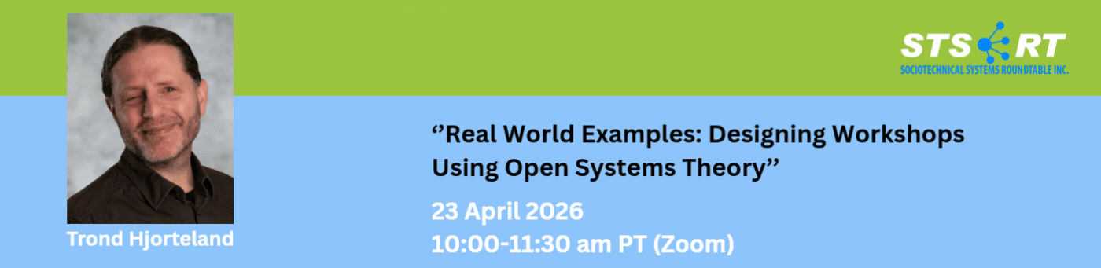

Meeting notes

Overview
This session explored how open systems theory, sociotechnical systems design, and participatory design can make software work more humane, adaptive, and effective. Trond Hjorteland traced his path from coding and architecture in the IT industry to using workshops and surveys to redesign teams and work structures so they better fit the social and technical realities of organizations.

Key Themes

From coding to sociotechnical thinking
- Trond described his career progression from programmer (starting in 1999) to architect and then to someone focused on how software work is organized socially, not just technically.
- He emphasized that software development is not just about code structure, patterns, and architecture, but also about how people collaborate, communicate, and make decisions.
- He connected earlier technical interests—such as design patterns, domain-driven design, and service orientation—to later concerns about team structure and organizational design.

Why Agile helped, and where it fell short
- He presented Agile as an important break from Waterfall’s slow, upfront design model, especially through iterative delivery and self-organizing teams.
- He noted that Agile’s core ideas fit well for single teams, but it does not adequately address scaling, inter-team coordination, or the broader organization.
- A major critique was that Agile often reduces work to the technical side, while leaving coordination, goal-setting, and social dynamics underdeveloped.
- He argued that many Agile implementations became “feature teams” working in isolated pockets, often disconnected from end users and broader business decisions.

Conway’s Law, team structure, and organization design
- Trond highlighted Conway’s Law as a key insight: system architecture tends to mirror communication structures in the organization.
- He explained that if teams are structured around layers or silos, the software often becomes layered and siloed too.
- He used examples from large telecom systems with hundreds of developers to show how poor team boundaries create duplication, conflict, and dependency problems.
- He also discussed the importance of designing teams intentionally rather than assigning them casually or letting management/HR define them without technical and social understanding.

The shift to open systems theory and DP1/DP2
- Trond said the major breakthrough came when he began reading open systems theory, Fred Emery and Marilyn Emery’s work, and related sociotechnical research.
- He contrasted DP1 with bureaucratic, control-heavy organization and DP2 with participative, self-designing team structures.
- His central claim was that Agile generally gets stuck in a laissez-faire or mixed-mode state: small pockets of autonomy exist, but the overall organization remains bureaucratic and hierarchical.
- He argued that DP2 offers a better path for scaling self-management because teams design their own work and relationships rather than being imposed on from above.

Participatory design and large-group methods
- Trond described participatory design as a practical method for moving toward DP2.
- He referenced two key practices:
  - Search conferences: collaborative planning/design sessions with no leader taking over.
  - Participatory design workshops: sessions where people design their own work and team arrangements.
- He stressed that these methods work because the people doing the work are the experts in their own system and need to create the design themselves.
- He presented these as more than facilitation techniques—they are mechanisms for building motivation, responsibility, and commitment.

Workshop Examples He Shared

Pre-mortem workshop using participatory design principles
- Trond described facilitating a pre-mortem workshop for 20–30 participants.
- Participants first worked in small groups to identify what could go wrong, then the ideas were consolidated into one shared list.
- The group voted on the highest-priority risks, formed interest-based subgroups, and developed prevention ideas.
- He noted that this was inspired by search conference principles and gave participants ownership over the output.

Team redesign workshop in a siloed organization
- He also described a participatory design workshop for a company that had recently reorganized teams into silos.
- The teams worked on different applications and struggled to integrate changes across channels.
- Participants were asked to design how their teams should look and how processes should work if they were free to redesign them.
- The workshop produced multiple proposals and at least one agreed direction, though he was unsure how much the organization implemented afterward.

Using the standard work-survey instrument
- Trond explained that for redesign workshops, he sometimes uses a survey instrument developed in the sociotechnical tradition.
- The survey measures how people feel about their work, including psychological requirements and whether work is meaningful, supportive, and future-oriented.
- He said this survey is especially useful when teams are redesigning their own work, because it gives a baseline and shows whether the new design improves the system.
- He noted that high scores on the “desired future” dimension can indicate strong control in one person and little ownership across the rest of the team.

Research and Evidence He Highlighted

Trond and Marilyn Emery collaboration
- Trond shared that he collaborated with Marilyn Emery on a study bringing her work-psychology survey into the IT industry.
- The study examined how work affects mental health and how democratization in IT since the 2000s has or has not changed people’s experience of work.
- He said being included in the introduction of the paper was a point of pride for him.

The 2021 paper on “digital coal mines”
- The presentation referenced a 2021 paper with Douglas Austrom on social-technical systems and digital “coal mines.”
- The paper served as a bridge between classic sociotechnical thinking and modern software organizations.
- Trond used it to show that concerns about work design, democracy, and control are still highly relevant in contemporary digital work.

Survey findings and correlations
- Trond discussed Marilyn Emery’s causal path analysis and correlation work using survey data from IT workers.
- He pointed to strong relationships between laissez-faire, bureaucratic control, team control, equality, job satisfaction, and job search behavior.
- He explained that in some IT contexts, Agile creates pockets of control for developers, but the broader organization remains confusing and hierarchical.
- He characterized this as a “patchwork of contradictions” in software organizations.

Core Conclusion
- Trond’s main conclusion was that software organizations cannot be improved sustainably by focusing only on engineering processes or team-level agility.
- To truly scale, organizations need to move from bureaucratic DP1 structures or unstable laissez-faire pockets toward DP2: self-managing teams that design their own work and coordinate across boundaries.
- He argued that this requires participatory design, not expert-driven design, because only the people doing the work can genuinely own and sustain the system.
- His closing motto was that one does not simply impose the design; it must be created by the people who will own it.

Closing Notes
- The conversation ended with appreciation for the talk and an announcement of an upcoming session with Anne Louise Howard on ‘Designing for gender equality in engineering’
- The group also noted the annual international conference in Berlin scheduled for September 29 to October 2, with registration expected to open soon.

