Reconciling Top-Down and Bottom-Up Lean Implementation

by Mr. Jean Fuller,

Work Design, Montreal, Canada
This case study demonstrates how Lean and STS methodologies were both utilized in a plant that built light aircraft. The aim of the change project was to improve downstream on time delivery, product quality, cost effectiveness and employee engagement vis-à-vis their products. After more than seven years, this redesign is still in use. Business objectives and employee engagement goals were more than achieved.
Plant management had initiated an approach to implementing lean/Six Sigma practices using a team model. This was driven top-down. The goal was to certify teams in their utilization of lean tools and concepts as well as implementing team management practices. The project described below provided bottom-up involvement and ownership to designate the milestones with which team management practices would be incorporated into the lean team certification process for all units in this plant.
The contributions of Lean and STS methodologies to this effort can be described as follows:

Characteristics of the STS designed Product Teams that were deployed:
- Accountable for on-time delivery of parts to downstream work teams using direct interface with these teams to determine parts and quality needs
- Daily work plan developed by the team to meet downstream customer needs
- Contribution to the transformation and delivery of parts both within and outside their functional areas of work – multi-skilling for parts quality and delivery
- Contribution to the cost reduction efforts (as per benchmarking/competitiveness needs)
- Regular assessment of employee motivation for intrinsic and extrinsic needs

Contributions of Lean/Six Sigma methodology within this change project:
- Statistical process control of all parts being manufactured
- Identification of parts that have poor performance
- Support and guidance of improvement efforts/projects for designated parts

Background
The organization is a Canadian manufacturing and assembly plant of light aircraft that was built in an economically depressed area in the early 1980’s. With government assistance, this plant became very successful and profitable. During its creation, it developed a culture of employee participation as part of the preparation for an STS, team based organisation model that was developed at that time by another consultant. That model was not implemented in1986 because of changes to the aircraft models that were to be produced. However, the dialogue that had been created with employees and managers of all levels was maintained and explains a good part of the plant’s success. It achieved production and safety records and has a history of on time delivery that is among the best in the business.
At the time this project took place, this facility employed 2100 employees and produced a variety of commercial models; heavy duty for mining, oil and construction industries as well as a variety of small and medium size aircraft for private owners, surveillance aircraft for police corps, commercial transport and ambulance, to name just a few. Its customers were from all parts of the world. It was renowned for the quality of its products.
This organization was ISO certified with high quality and safety industry standards. Yet it was loosely structured, relying on dialogue with employees through a variety of committees to manage manpower scheduling, training, compensation, employee relations, etc.
The plant was structured around “mini-business units”, each with its own support staff – engineering, logistics, scheduling, quality control, etc. This structure had been defined by local managers and it was still in its initial implementation phases at the time this project took place. The centralized support functions were design engineering, IT, Finance, Maintenance, HR and Six-Sigma.
This case study describes a redesign in one of these business units – the composite parts’ business unit.
The parent company, owner of this plant, introduced a Six-Sigma Program at the turn of the 21st century.
The Six Sigma program was managed in a top down mode with management and staff employees volunteering to carry out improvement projects in an area of the plant they had selected so as to become “Green or Black Belts.” Their project was approved by local and corporate management.

Phase One – Discovery
The manager of the composite materials’ business unit understood something was wrong with the structure of his organisation. Efficiencies were tightly managed. The time it took to make parts, the quality issues related to these parts and, naturally, the costs were the main concerns in the management processes being used since his arrival a year prior. His business unit had good performance insofar as these indicators were concerned.
However, he and his management team, which acted as a steering team, constantly struggled with “on time delivery” of parts to downstream customers that used these to build, assemble and test the light aircraft this plant made. On time delivery was only 48%. He and his staff spent countless hours trying to make sense of what was really being produced so as to give accurate dates to downstream customers. Also, they realized that the parts being made spent 90% of their time on shelves (work in progress), waiting to be processed and delivered. Something was very wrong.
At another level, management staff was not utilizing its expertise to the fullest. They were spending too much time, as a team and individually, scheduling and second guessing which parts could be delivered. Also, they were spending a significant amount of their time “chasing” down parts that were on the verge of work stoppages for their downstream customers.
When examining the way a supervisor would personally take responsibility for a part that was a “show stopper” for a downstream customer, they realized that one of the main causes for poor on time delivery was a lack of accountability within their organization for what was being produced. People were accountable for the time and the quality of the parts they made but not for their delivery. But how could they do this given the complexity of the unit’s transformation process? Making parts out of composite materials is not a simple task. It requires specialized, costly materials and equipment as well as a high level of expertise from specialists at every step in the process. To minimize this expertise would result in poor quality and an increase in production time and costs. The following is a map of the production process being used as well as downstream customers.
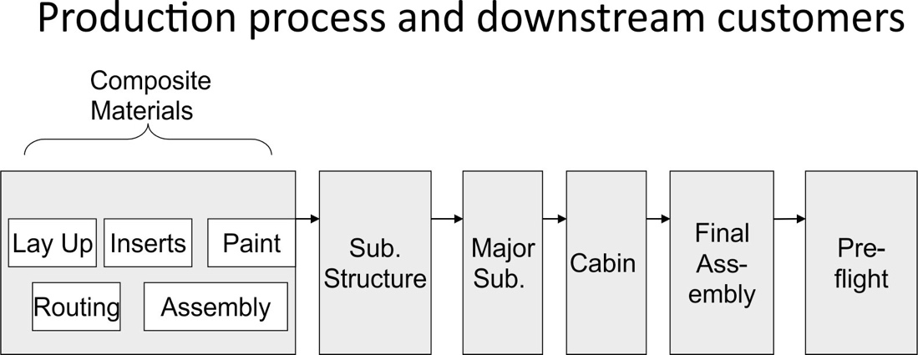
It is at this time that the idea of creating “product teams” began to take shape in the business unit’s manager’s mind and in dialogue with his steering/management team.
Outside help was then involved. The consultant hired to provide assistance was already working with plant management. He raised the issue that yes, this was a plant where there existed a strong “employee involvement” culture but, he pointed out that this involvement process was mostly focused on topics related to human resource management. At this company, employees had a significant say in establishing and applying policies relative to all issues in the realm of human resources. Only in rare occasions did management have to make a unilateral decision, even in situations where temporary layoffs had to be made. Participation in other areas was more arbitrary and not systematic.

Phase Two – The Dream: Product Teams
Involvement of employees in developing the dream of teams built around and taking responsibility for the process became the necessary next step. The management team was well aware that the management culture of the business unit was based on efficiencies. People were proud of this despite the fact that product delivery dates and quality were not meeting customer expectations. It became important to take on a different perspective.
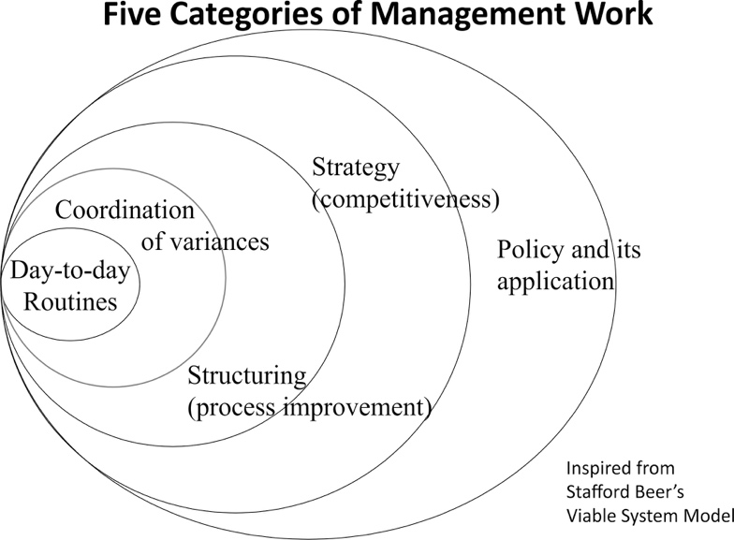
Prior to the beginning of this project, the plant management team, including the business unit managers, developed a “future state” vision of employees’ and managers’ involvement in day-to-day decision making. Using Stafford Beer’s “Viable Systems Model”, it defined deliverables for employee, staff and management personnel. Beer defines management as being made up of five interdependent systems. For the sake of this project, these five systems were defined as being the processing of pertinent information for decision-making in five different systems:
- System one: the execution of day-to-day tasks required by the unit’s (team, department, etc.) mission
- System two: the resolution of recurring problems (variances) related to the execution of day-to-day tasks required by the unit’s mission
- System three: the structuring of processes (business, transformation, management or otherwise) and roles/contributions of the people involved, concerned or impacted
- System four: the formulation and review of business strategy
- System five: the formulation and application of policy to make these systems work
The Composite Materials’ Business Unit management/steering team used this future state vision to create a draft of how product teams could work. It would later ask the pilot/design team to see if this was a relevant idea to implement. This work was carried out by members of the business unit management team. Within this framework, employee participation took on another meaning since it was not limited to human resource management. Within this framework, employees’ were recognized for their knowledge the business as it relates to the execution of day-to-day tasks.
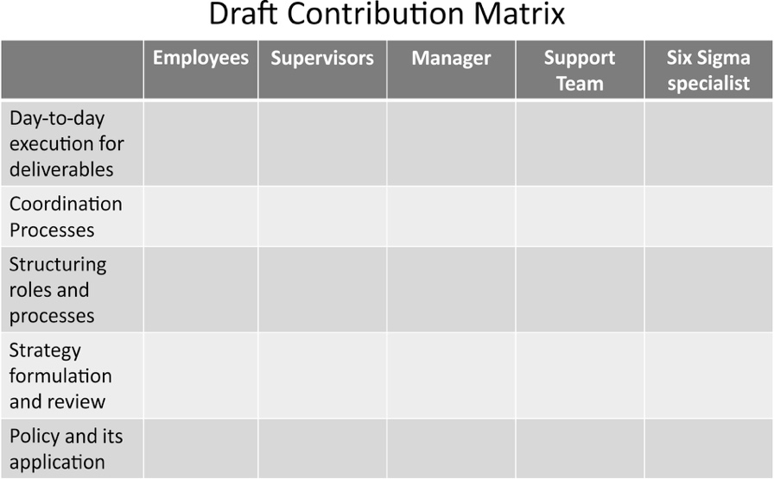
The management team, in its steering committee role, decided to involve employees in the “discovery” process. It set up a series of meetings during which they shared the results of their business case as well as their thinking as to the creation of product teams. Given the plant’s priorities for aircraft delivery, the product team to be the focus of the experiment was mandated to focus on one particular set of parts for two specific downstream customer teams.
The management team received support from employees’ for this new level of thinking as demonstrated by the number of them who volunteered to be part of the pilot project.
The management team created a charter for a pilot team made up of 22 people from five areas of the business unit (assemblers, dispatch, technologist, QC inspector and one supervisor). Three other areas within the business unit were designated as service centres since they contributed to all composite parts made. The pilot team’s initial mandate was to put together a team design that would improve on time delivery to at least 75% within three months without reducing quality and nor increasing costs. Members of the pilot team were to remain in the functional areas except for those tasks related to the delivery of their team’s parts.

Phase Three – Design
Once recruited, the members of the pilot product team, acting as a design team, went through start up and design activities that included the following:
- A work system simulation to highlight the differences between a classical organisational model resting on functional silos and on specialized functional jobs (scientific management approach) versus a work system that uses multi-skilled teams.
- The application of these ideas to the product team they were to experiment. The team developed a matrix model in which they remained in their functional areas but to only work on the parts that were part of the Product Team’s charter. In addition, team members were to take on tasks related to product delivery, helping out colleagues in their transformation process, quality checks and the training of Product Team members for multi-skilling.
- The definition of performance indicators to measure customer satisfaction, quality, costs and employee engagement.
- The definition of management processes to apply the product team approach – daily, weekly and monthly reviews as well as the progression of employees in their engagement towards team goals and multi-skilling.
- The multi-skilling needs of their team to reach their goals while ensuring that functional expertise was not diminished.
- The design team asked the Six Sigma person to support them in the problem areas they identified that were inhibiting on time product delivery, quality and costs.

The design team also defined a plan to meet its pilot project goals within the three month timeframe it was given. This plan included a communication strategy to inform the people impacted of their mandate and of their progress.

Phase 4 – Deploy/Develop
Reaction to the implementation was very positive since it was unusual to see assemblers meeting their downstream customers to discuss their needs. Under the plant’s structure, these communications were usually carried out by supervisors or by support team members. The peer to peer relationships introduced by the Pilot Product Team generated a lot of excitement as well as collaboration and encouragement for the members of the Product Team.
The major challenges they encountered were:
- Becoming skilled in an area other than the one the person normally worked in – took more time than expected. Visual instructions were eventually introduced to facilitate the acquisition of new skills.
- Quality inspection became a bottleneck since too few persons were qualified in the three month period
- People complained there were too many meetings and not enough work was being done
- The supervisor’s work load was significant at the beginning until team members also took on some the reporting tasks
- Some of the service teams within the business units were not always eager to modify their schedule to meet the pilot product team’s needs
It only took a few weeks to reach the 75% on time delivery target. At the end of the 3 month period, the team was achieving more than 80% on time delivery, quality was improved as well as costs reduced.
There was no hesitation to introduce the Product Team concept across the Composite Materials’ Business Unit. Downstream customers’ needs were the basis for the creation and implementation of other product teams. Over a period of 15 months, the conversion to product teams was made across the Composite Materials Business Unit, including its service teams. On time delivery of parts to downstream customers was no longer a lingering issue to deal with.
And, yes, management staff time chasing parts was greatly reduced.

